Final project
Good [morning/afternoon], everyone. I'm Abhirami Kannan, and today I'm excited to present my final project titled ‘SafeCryptoStocks.’
This project is a microservices-based application designed to manage cryptocurrency portfolios and stock trading activities.
My focus was on infrastructure as code, security, and multi-region high availability using Microsoft Azure and Terraform.
have successfully deployed its core infrastructure on Microsoft Azure, leveraging key cloud-native services for scalability, security, and automation.

I’ve built a fully automated, scalable, and secure Azure infrastructure that includes Kubernetes clusters, managed identities, key vault integrations, and more — all defined and deployed through Terraform.”

- Infrastructure:
  - Configured Azure Storage Account backend to store the Terraform state remotely using:
  - Rg,storageacc,container:tfstate,statefile
  - Compares the .tf file and remote state file and do apply… and team collaboration works can be done..if 1 doing the state is lock…changes applied to state file
  - Created a resource group
  - Deployed acr- Admin access enabled, Assigned a System Assigned Identity
  - why?
    - Admin access enabled:
      - Static username,password
      - Security issue,vulnerabile,may get leak
      - Useful for quick testing or initial setup, especially when you want to:
      - Manually docker login,push pull images from ur locl, but not recommented in production:

    - This enables username/password-based authentication (admin credentials) for ACR.
    - System assigned identity:
      - Allow ACR to authenticate to other Azure services without storing secrets.
      - Acr can securely talk to other azure services Eg:Accessing Key Vault (if ACR ever needs secrets or certificates)
      - t's a best practice to always enable Managed Identity, even if not used immediately. It provides secure, passwordless authentication in future integrations.
      - Even if ACR doesn't immediately need to access another Azure service, enabling this identity is a best practice. It means if, in the future, you want ACR to, for example, push logs to a Log Analytics Workspace, or pull a certificate from Key Vault, it already has an identity ready to be granted permissions.

      - It's for ACR itself: This identity is for the ACR service to access other Azure services. It's not for your AKS cluster or pipeline to access ACR (they use Service Principals or their own Managed Identities for that).
  - 2 vnets –(public/private) ,each vnet 2 subnets
  - Vnet in central india and west Europe
  - Subnet1: For default AKS node pool
  - Subnet2: For user AKS node pool
  - Created a user assigned managed identity to allow aks access to azure key vault secrets using csi driver
  - Created 2 aks clusters -1 per region
  - Enabled Key Vault CSI Driver for secrets management
  - Was configured with the User Assigned Identity
  - Created 2 keyvaults but using only 1 keyvault used by both clusters and granted access to key vault secrets
  - Added access policies? Y?
  - Terraform executor identity full secret permissions
  - Gave AKS managed identity Get and List access
  - Created secrets in both keyvaults (DbUsername and DbPassword)
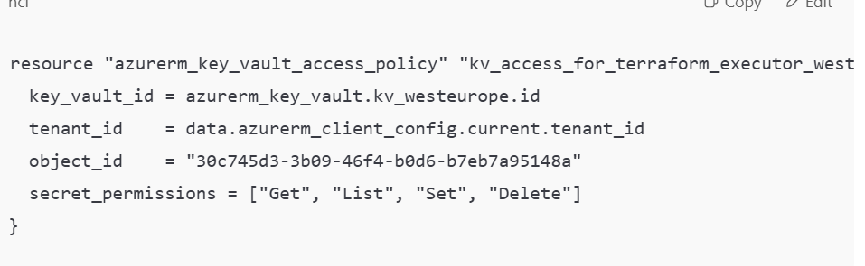
Terraform executer(me) getting full access for west Europe key vault-not using,full control over secrets

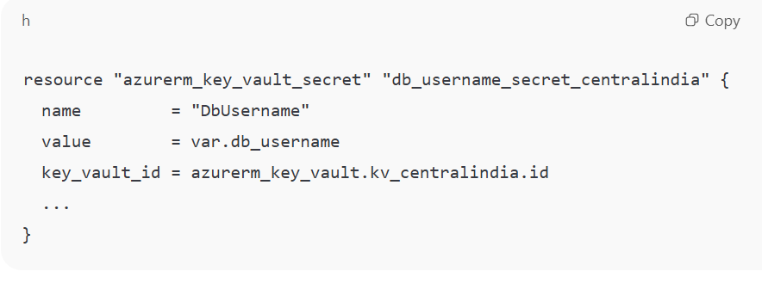

Creating secrets:the secrets are pulled from sensitive input variables
(var.db_username,var.db_password)
Depends on : ensuring the executing access policy is there before trying to store secrets

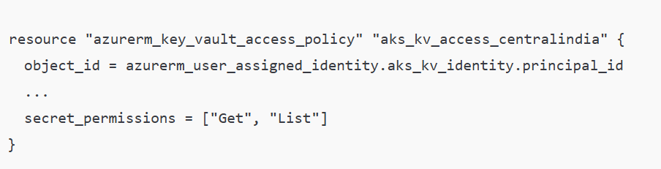
Grant aks cluster 1 – min permission to read secrets(through user assigned managed identity)
- AKS uses this to retrieve values via CSI driver mounted into pods.
- Given access to west Europe aks to access secrets
- Creating secrets for west Europe

Summary:
"I built a multi-region, high-availability infrastructure on Azure using Terraform. It includes two AKS clusters, secured with a user-assigned managed identity that integrates with Azure Key Vault. Secrets like database credentials are stored securely and automatically rotated via the CSI Secrets Store Driver. The state is managed remotely using Azure Storage Account backend for collaboration and consistency."

Secrets Store CSI Driver: This is a powerful Kubernetes add-on that allows our pods to directly mount secrets from Azure Key Vault as volumes within the container's file system. This means applications can simply read secrets from files, without needing to know Key Vault APIs.

SecretProviderClass: This custom Kubernetes resource acts as the bridge between our pods and Key Vault. It defines which Key Vault instance to connect to, which specific secrets to fetch, and which Managed Identity (the CSI driver's identity) to use for authentication.

imagePullSecrets: We've configured our deployments to use imagePullSecrets, which allow our AKS nodes to securely authenticate to ACR and pull the necessary Docker images.

Challenges:
"Multiple user assigned identities exist" Error (for userservice and initially portfolioservice):
Problem: Pods were failing to mount secrets from Key Vault because the Secrets Store CSI Driver was confused by multiple Managed Identities on the AKS node. This was caused by an incorrect configuration where the clientID was being injected directly into the Deployment YAML, conflicting with the SecretProviderClass
ImagePullBackOff / 401 Unauthorized Error (for portfolioservice):
Give annotation to deployment file

"Control Plane Deallocated" Error: iiht issue

Service principle:
  - I created
  - Given role as storage blob data contributer: read and write blobs in tfstate
  - Service Principal (abhi-pipeline-sp) has more than enough permissions to perform all deployment-related tasks, including pulling images from ACR and deploying to AKS! The Contributor role at the subscription level covers ACR access
Key vault:
Given role: key vault secret user
Read secrets inside the vault

KEY vault and secret class provider and the managed identity:
created key vaults: securely stored secrets inside that key vault like usernamepassword,mogo-uri
and created a managed identity: to access secrets and the secret store csi can use to authenticate to key vault without managing passwords
also given access policy to managed identity as get and list the secrets
also i have enabled the csii drivers in my terraform code: to allow our aks pods to mount secrets from key vaults directly into thir file sysytems as volumes ,which simplifies secret access for application-secured way
and i have deployed the 2 secret provider class into both clusterss:
it provides the instruction for the csi driver to access which key vault to connect and retrive the secrets
so the pod can access the secret through the secret provider class

